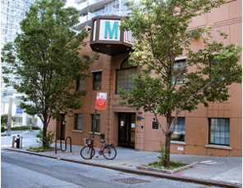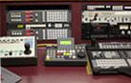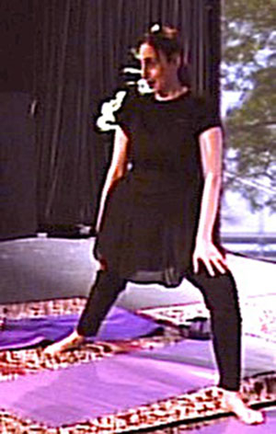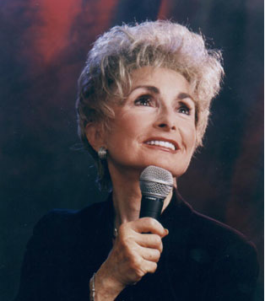

**Rebbetzin Esther Jungreis** on **Healing is Appealing TVShow,** *Producer* Adina Marmelstein, will be speaking on "**Spiritual Healing**".

Be the Audience and watch this TV Production.

**RSVP** [Healing_is_Appealing@yahoo.com](http://us.mc1108.mail.yahoo.com/mc/compose?to=Healing_is_Appealing@yahoo.com); large space will fill.

Feb. 15, Wed. Seating at 730pm, recording promptly 8pm-11pm.

A/C/B/D/1, M10,M104, M57, M11, M7 buses.

Approx. 103,000 subscribe to TWC, RCN, FIOs.

537 west 59th street. Btw. 10th-11th Ave. **BE ON TIME!!!!!**

Rebbetzin Esther Jungreis on TV.   
Producer Adina Marmelstein. **Be the Audience**.

730 pm

**February 15**